NAME:___________________________________________________

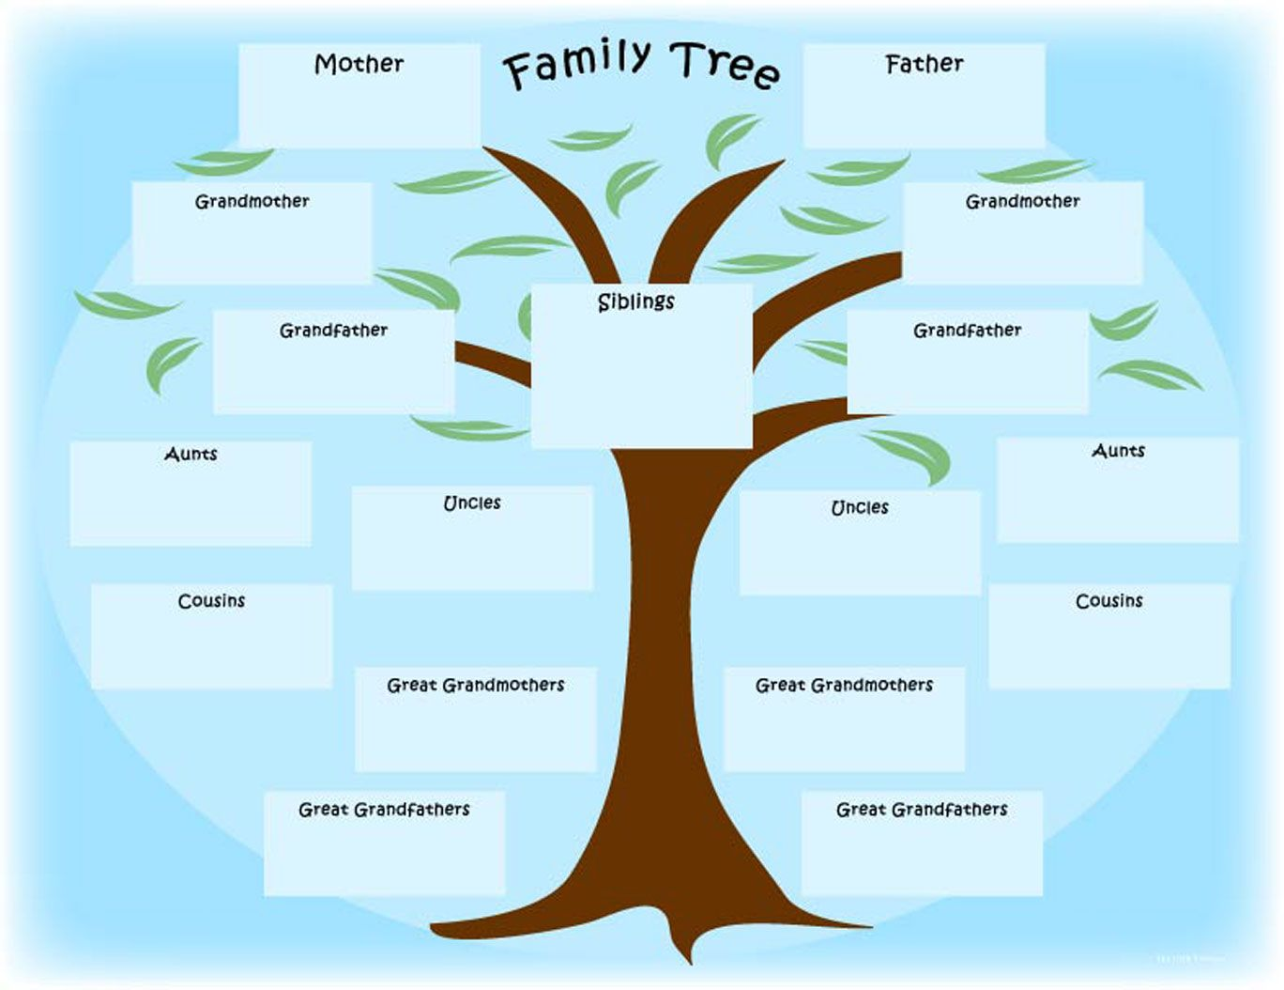

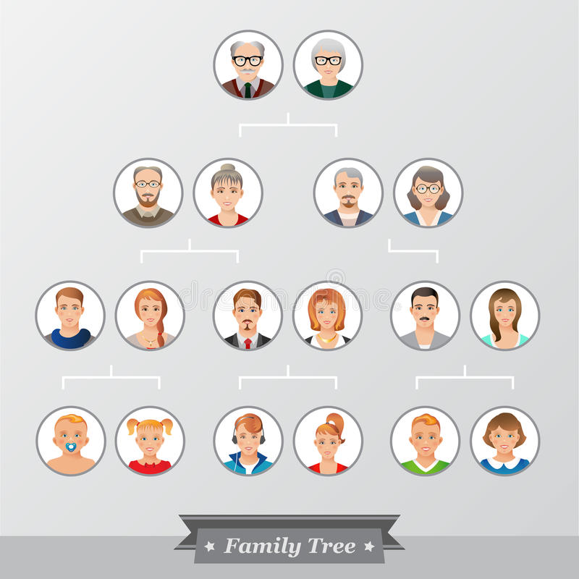

NAME:____________________________________

FAMILY TREE